***Estonia has world’s first nationwide electrical vehicle fast-charging stations with 165 stations.***

**Estonia**

Most of countries official priorities are the reduction of negative effect of energy usage on environment, the promotion of resource efficiency with sustainable consumption and production patternsare, reduction in CO2 and other pollutant. Estonia is a good example which trying through electric mobility development achieving these goals. Estonia may not be the first country that comes to mind when you think of electric cars, but the small Eastern European nation was actually the first country in the world to install a [nationwide network of electric vehicle fast chargers](http://cleantechnica.com/2013/02/23/estonia-is-1st-country-in-the-world-to-install-nationwide-system-of-fast-chargers-for-evs/) .By the beginning of 2013,165 fast chargers have been installed around the country for the comfort of EV users.This report intends to provide a fact-based perspective on the status and current developments of the electrical car charging stations in Estonia.

**Background**

According to the Kyoto Protocol, Estonia had to reduce its greenhouse gases emissions by 8 % in comparison with its 1990 level between 2008 and 2012. Estonia is participating in two Kyoto flexible mechanisms – international emissions trading and joint implementation. In March 2011, the Government of the Republic of Estonia concluded a contract with Mitsubishi Corporation for the sale of AAUs in the amount of 10 million AAUs to start the Estonian electrical mobility program. The program consists of three parts: 507 Mitsubishi iMiev electric cars were commissioned by the Ministry of Social Affairs as an example,. Distribution of the purchase grant and the administration of the fast charging network are organized by Foundation KredEx.

**Electrical vehicle in Estonia**

As Demo experience, the Ministry of Social Affairs took 507 Mitsubishi i-MiEV electric cars into use in 2011, that's the largest single order Mitsubishi has ever received for its little car. Estonia electrical vehicle market is very small due to Estonia’s small population which is 1.34 million, but look like most other markets Nissan Leaf is the favorite electrical car for individual buyer in Estonia.

---------------------------------------

69% of the market was occupied by Nissan Leaf , the Mia Electric and Mitsubishi i-MiEV just sold 22 and 20 cars respectively, Tesla Model S just sold 1 unit in 2013.

there is one electric car registered per each 1,000 cars in Estonia, the respective figure for Norway is four.

-------------------------

One registered EV per 1,000 cars (grey quote)

-------------------------------

**Electrical Vehicle Charging infrastructure**

Estonia has becam the world’s first country to launch a nationwide fast-charging network for electric vehicles.

The EV fast-charging network is operated by a national foundation KredEx, the chargers were produced and installed by a technology company ABB, the innovative payment solution was designed by NOW Innovations, and customer support is provided by a security company G4S.

-------------------------------

ABB’s fast charging station they conform to the CHAdeMO standard, and each features a 50 kW DC and a 22 kW AC outlet.

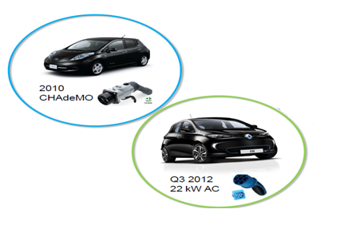

The car’s battery can be charged up to 90% in less than 30 minutes and depending on the model you will be able to drive for up to 140 km.

--------------------------

The car’s battery can be charged up to 90% in less than 30 minutes (green quote)

------------------------------------------

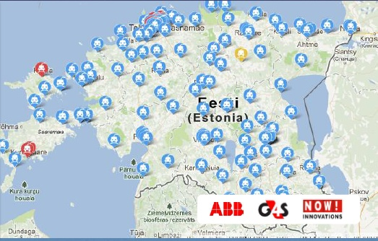

Fast-charging points are distributed at all roads with dense traffic are covered,the distance between quick charging points is 40-60 km Suitable and frequently visited places are considered as locations for quick charging stations, e.g. petrol stations, cafes, shops, etc, and all settlements with over 5000 inhabitants.

**EV Charging Payment Support**

Fast-charging network users are offered three service packages to choose from: Combined package, Flex package, Volume Package

Payments can be made using an authorized card (RFID card) or mobile phone. The uniform payment solution can encourage the growth in number of EVs users.

**Improving EV’s user adoption**

ELMO program by offering rental service to Estonian is seeking for improving EV adoption rate in Estonia. 18 Nissan Leafs and 6 Mitsubishi iMiEVs are available for rental from outlets in Tallinn and Tartu. the rental just cost 8-10 Euros to rent an EV in Tallinn and user just need to use a Smartphone application or call a number to unlock a car.  
**Government EV Incentives**

Besides having a public fast-charging network, Estonia promotes a quicker deployment of EVs by providing direct support to both private persons and companies, with the amount reaching up to 18,000 Euros of the all-electric car’s purchasing price. Also, new EV owners can apply for a support of 1,000 Euros for setting up a charging system at their home.

-------------- 18,000 Euro per EV, 1,000 Euro per setting EV charger at home----------------

Problems and solutions:

1- Estonia use Oil shale for generating electricity which is not environment friendly. Estonia needs to switch to other energy sources.

2- Most of Estonian still have range anxiety and worry about EV reliability, there should be a nationwide education plan for improving EV adoption between Estonian

3- Harsh winter can effect on the EV battery function and operation, battery manufacturer needs to produce suitable battery for cold winter in Estonia.

4- There is not enough EV model diversity in Estonia , one reason can be there is not any supercharger for some electrical cars like Tesla which take longer time than other EVs to get charged.

**Bibliography:**

**1-** [**http://en.wikipedia.org/wiki/Electric_vehicle_network**](http://en.wikipedia.org/wiki/Electric_vehicle_network)

**2-** [**http://elmo.ee/en/**](http://elmo.ee/en/)

**3-** [**http://www.abb.com/cawp/seitp202/61df2f8f8c7d00a6c1257b18002d5e3c.aspx**](http://www.abb.com/cawp/seitp202/61df2f8f8c7d00a6c1257b18002d5e3c.aspx)

**4-** [**http://www.abb-conversations.com/2014/02/top-electric-cars-in-17-european-countries-charts/**](http://www.abb-conversations.com/2014/02/top-electric-cars-in-17-european-countries-charts/)

**5-** [**https://creativesustainabilitymarketing.wordpress.com/2013/03/25/the-history-of-bias-the-ethics-behind-estonian-electric-cars-project/**](https://creativesustainabilitymarketing.wordpress.com/2013/03/25/the-history-of-bias-the-ethics-behind-estonian-electric-cars-project/)

**6-** [**http://investinestonia.com/en/business-opportunities/smart-mobility**](http://investinestonia.com/en/business-opportunities/smart-mobility)

**7-** [**http://estonianworld.com/technology/estonia-becomes-the-first-in-the-world-to-open-a-nationwide-electric-vehicle-fast-charging-network/**](http://estonianworld.com/technology/estonia-becomes-the-first-in-the-world-to-open-a-nationwide-electric-vehicle-fast-charging-network/)

**8-** [**http://www.plugincars.com/estonia-another-ev-leader-northern-europe-126505.html**](http://www.plugincars.com/estonia-another-ev-leader-northern-europe-126505.html)

**9- Electric vehicles in Europe: gearing up for a new phase?, Amesterdam Roundtable Foundation, 2014**